ASSIGNMENT 9
1.
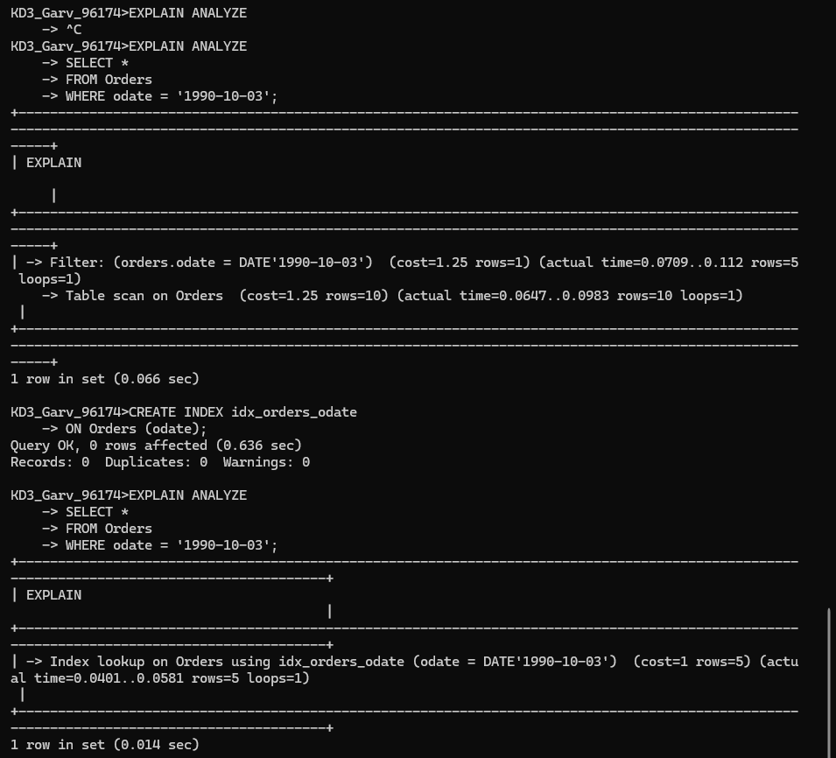
2.
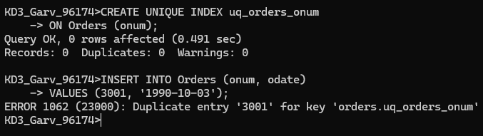

3. 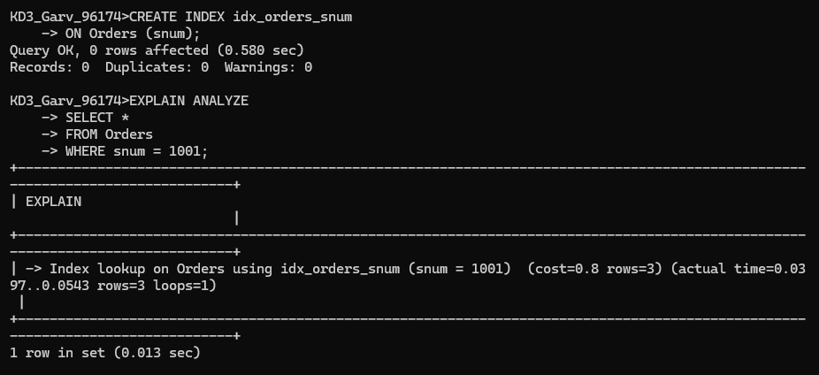

4.
CREATE UNIQUE INDEX uq_salesperson_rating
ON Customers (snum, rating);

5.
